**Steps to Run the Test**

1. Install testing dependencies (if not already installed):

npm install --save-dev @testing-library/react @testing-library/jest-dom jest

For TypeScript projects, also install:

npm install --save-dev @types/jest

**. Configure Jest (if not already set up)-🡪 this file is optional**

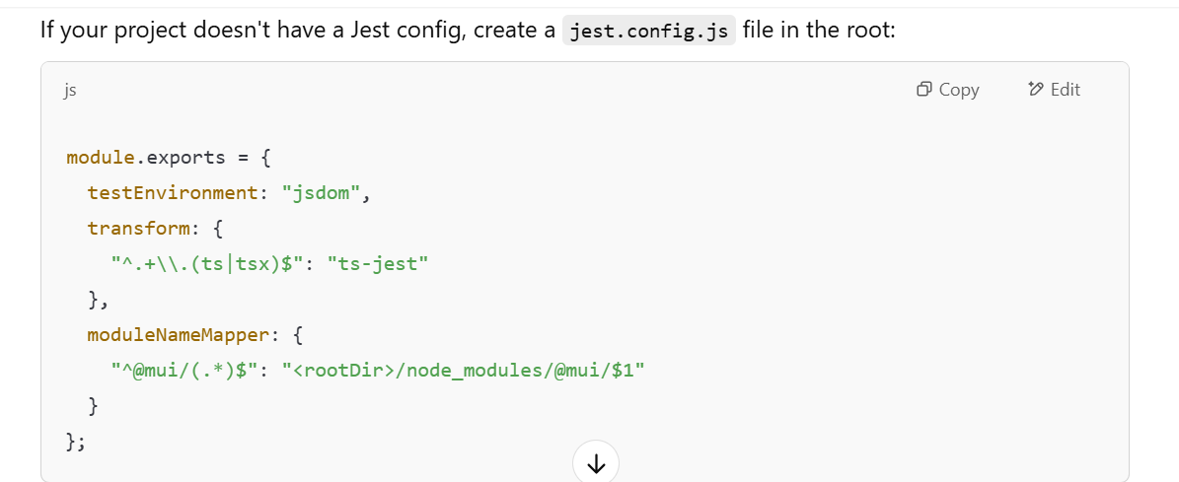

Because:

**Jest's built-in defaults and React's testing setup**. Here's why:

**1. Jest is Preconfigured in Create React App (CRA)**

If your project was created using **Create React App (CRA)**, it comes with Jest preconfigured.

* CRA automatically sets up **Jest** and **React Testing Library**.
* You can run npm test without any additional config.
* CRA internally manages the jest configuration using react-scripts.

👉 **Check if you're using CRA:**  
Look at package.json—if it has "react-scripts" as a dependency, you're using CRA.

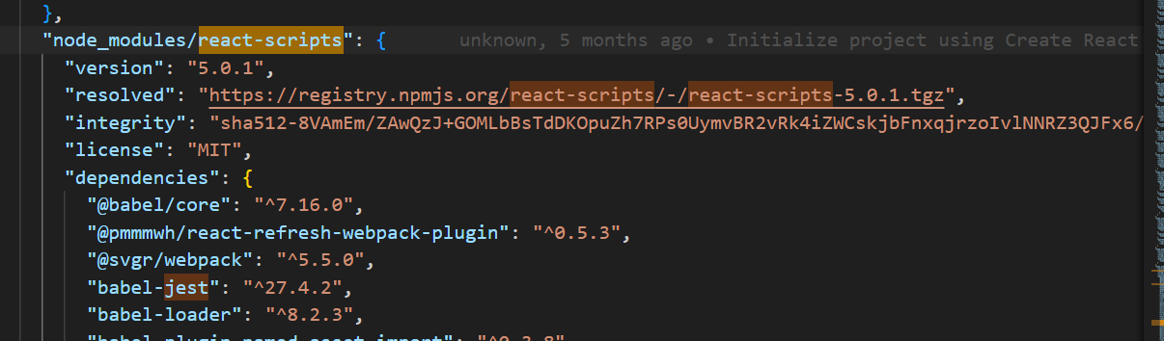

**2. Jest Has Built-in Defaults**

Even if you're **not using CRA**, Jest works **without a config file** because:

* It has **sensible defaults** (e.g., uses jsdom for testing React components).
* It looks for test files matching patterns like:
  + *.test.tsx or *.test.js
  + *.spec.tsx or *.spec.js
* It automatically recognizes TypeScript if ts-jest is installed.

**3. TypeScript Works Without Explicit Config**

Since Jest supports TypeScript via ts-jest, it works automatically if:

* You have TypeScript installed (npm install typescript).
* The test files have .test.tsx or .test.ts extensions.

**4. MUI Components Work Due to Module Resolution**

Even though MUI (@mui/material) uses ES modules, Jest automatically handles them. However, **if you face module resolution issues**, you may need to add a custom jest.config.ts.

**When Would You Need a Jest Config?**

* If you want **custom configurations**, like:
  + Setting up **alias paths** (@/* imports).
  + Mocking file imports (.svg, .css).
  + Using different test environments (e.g., node instead of jsdom).
* If your project **isn't CRA** and you want to manually configure Jest.

**TL;DR (Too Long; Didn't Read)**

✅ **Jest runs without a config** because it has defaults.  
✅ **CRA automatically configures Jest.**  
✅ **If needed, you can still add a jest.config.ts for customization.**

3. Run the Test

Use one of the following commands in your terminal:

Run all tests:

npm test

Run tests with coverage:

npm test -- --coverage

Run tests in **watch mode** (for continuous testing while coding):

npm test -- --watch

Run a **specific test file**:

npm test ErrorMessage.test.tsx

